Week 3 | Monday | Tuesday | Wednesday | Thursday | Friday
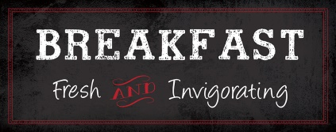 | Blueberry Muffin  Fresh Fruit  Fruit Juice  Variety of Fluid Milk | Apple Frudel  Fresh Fruit  Fruit Juice  Variety of Fluid Milk | Maple Waffles  Fresh Fruit  Fruit Juice  Variety of Fluid Milk | Breakfast Pizza w/Cheese & Turkey Sausage  Fresh Fruit  Fruit Juice  Variety of Fluid Milk | Cinnamon Roll  Fresh Fruit  Fruit Juice  Variety of Fluid Milk
 | Chicken Alfredo  w/Penne Pasta Roasted Carrots  Fresh Fruit  Variety of Fluid Milk | Walking Doritos Beef Tacos  Lettuce, Cheese Black Beans & Corn  Salsa  Fresh Fruit  Variety of Fluid Milk | Teriyaki Chicken  Seasoned Brown Rice  Roasted Broccoli  Fresh Fruit  Variety of Fluid Milk | Corn Dog  Potato Wedges  Fresh Fruit  Variety of Fluid Milk | Cheese Pizza  Steamed Green Beans  Fresh Fruit  Variety of Fluid Milk
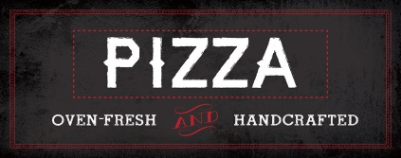 | Pesto Chicken  Cheese Pizza | Broccoli & Cheddar  Cheese Pizza | Spinach Pizza  Cheese Pizza | Buffalo Chicken  Cheese Pizza | Turkey Pepperoni  Cheese Pizza
 | Grilled  Chicken  Sandwich  Hand-Pressed Cheeseburgers | Double Dogs Sandwich  Hand-Pressed Cheeseburgers | Turkey  and Cheese  Panini  Hand-Pressed Cheeseburgers | Chicken  Parmesan Sandwich  Hand-Pressed Cheeseburgers | Spicy  Chicken  Sandwich  Hand-Pressed Cheeseburgers
Build-Your-Own Fresh Wrap
Choose from the following selections:
Chicken, Turkey, Tuna, Assorted Cheeses, Lettuce, Onions, Cucumbers, Pickles,
Honey Mustard, Mayo, Lite Ranch
Create-Your-Own Fresh Salad
Daily Choice of: Romaine, Spring Mix, Spinach
Protein Choices: Diced Chicken, Turkey, or Tuna
Assorted Toppings: Cucumbers, Onions, Tomatoes, Peppers, Chopped Eggs, Croutons, Shredded Cheese
Contact your Chef Resident Director at 216-295-4342 for questions or comments.
This institution is an equal opportunity provider.
Woodbury School

